Annex 6.2-K: Network Topology Diagrams

SHOC HQ Network Architecture
Note: Replace this text representation with actual network diagrams using Visio, draw.io, or similar tools.

Layer 1: Internet Edge

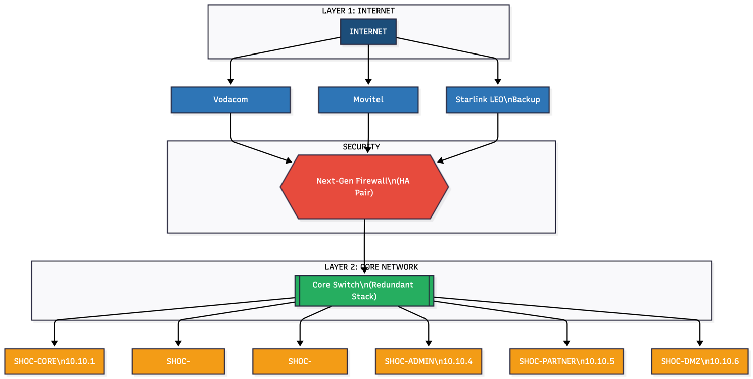

Network Component Registry
Asset ID | Device Type | Model | IP Address | Location
NET-001 | Primary Firewall |  |  | SHOC Server Room
NET-002 | Secondary Firewall |  |  | SHOC Server Room
NET-003 | Core Switch 1 |  |  | SHOC Server Room
NET-004 | Core Switch 2 |  |  | SHOC Server Room
NET-005 | Access Switch (Ops) |  |  | Operations Floor
NET-006 | Access Switch (Admin) |  |  | Admin Floor
NET-007 | WiFi Controller |  |  | SHOC Server Room
NET-008 | WiFi AP 1 |  |  | Operations Floor
NET-009 | WiFi AP 2 |  |  | Admin Floor
NET-010 | WiFi AP 3 |  |  | Situation Room

Diagram Version Control
Version | Date | Updated By | Changes

